1. **[Tool] ViVOPay_KeyLoading.exe**
2. 如果機器內已有key，先點”Erase ALL Keys”
3. 選 KPK Form, 按 Enter Key

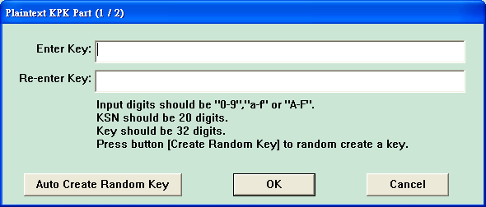

Key1 = (自動隨機產生即可)

Key2 = (自動隨機產生即可)

Key3 = (自動隨機產生即可)

OK後，按 “Load Key”

1. 選 DUKPT Key Form, 如果 load admin key, 則 Key Index 選”2”，按 Enter Key 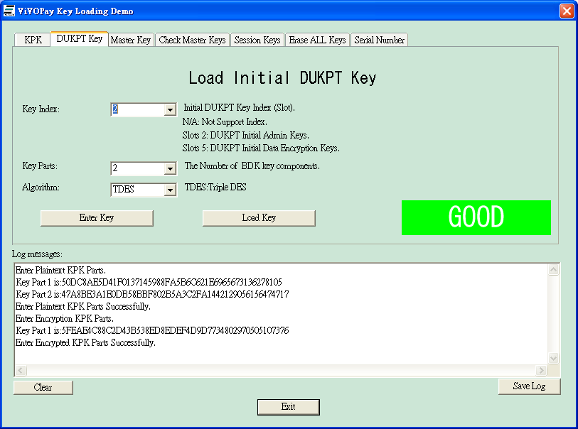

KSN = “629949FF000000000000”

Key1 = “00000000000000000000000000000000”

Key2 = “0123456789ABCDEFFEDCBA9876543210”

OK後，按 “Load Key”